**JYM-3A1 three-phase multifunctional**

**electric energy calibrator**

**Instruction Manual**

**Henan Singtront Technology Development Co., Ltd.**

**Contents**

Chapter I Overview 3

Chapter II Functions and Features 3

Chapter III Performance Index 5

Chapter IV Operating Principle 6

Chapter V Appearance and Structure 6

Chapter VI Wiring 7

6. 1 Start-up 8

6. 2 Voltage Wiring 8

6.3 Current Wiring 9

6.4 Photoelectricity Sampler 9

6.5 Power Pulse 10

Chapter VII Measurement 10

7. 1 Error Calibration (Integrated Measurement) 11

7.2 Input Methods of Letters, Chinese Characters (spelling) and Symbols 14

7. 3 Parameters Setting 16

7.4 Error Checking Measurement Interface 21

7.4.1 Monolithic Meter Error Calibration 22

7.4.2 Main and Auxiliary Meters Error Calibration (The error of two meters in identical type is calibrated simultaneously) 23

7.4.3 Multi-function Meter Error calibration (Active and Reactive Error are Calibrated Simultaneously) 24

7.4.4 Demand Measurement 25

7.5 Phase Measurement, Wiring Check, Electric Quantity Compensation 26

7.5.1 Wiring Check 28

7.5.2 Asymmetry Measurement 29

7.5.3 Measurement of Phase Asymmetry 30

7.5.4 Electric Quantity Compensation 30

7.6 Harmonic Analysis and Wave Form Display 32

7.7 CT Variable Ratio Test 33

7.9 Extended Function 37

7.9.1 Automatic Meter Reading 37

7.9.2 Import Data from U Disk 38

7.9.3 Export Data to U Disk 39

7.9.4 PT Secondary Voltage drop 39

7.9.5　PT Secondary Load Test 44

7.9.6 CT Secondary Load Test 45

Chapter VIII Instrument System Parameter Setting 46

8.1 Instrument System Parameter Setting 47

8.2 Instrument Brightness Setting 49

8.3 Instrument System Time Setting 50

Chapter IX Data Management 50

9.1 Condition Searching 51

9.2 New Library 53

9.3 Browse Library 53

9.4 Clear Library 54

Chapter X Interface and Definitions 55

10.1 Definition of Pulse Interface 55

10.2 Definition of Serial Communication Interface 55

Chapter XI Accessories 55

# Chapter I Overview

**JYM-3A1 three-phase multifunctional electric energy calibrator** is the newest product produced by our company by widely visiting users and referring to the advantages of the same kind of products home and abroad. The measured part of the product adopts high speed A/D transmission to send DSP to conduct digital processing, which largely improves measured degree of accuracy and stability. Central processing part adopts 32-bit ARM embedded technology to make instrument interface novel, function abundant, operation distinct and easy, and performance steady. Class of accuracy: Class 0.05.

# Chapter II Functions and Features

1. 7″ true color TFT light LCD with 800 X 480 resolution ratio is adopted. On the screen show all measurement parameters, vector diagram, degree of harmonic distortion and checking parameter setting. Interface need not be changed over to realize checking the electric energy meter error.

2. Touch screen and buttons can be operated more conveniently and quickly.

3. Voltage, current, power, phase and frequency can be measured at the same time and error calibrated; besides, voltage and current (between 2A and 10A) can automatically change gears.

4. Actual loading calibration of watt-hour meters with three-phase four-wire, three-phase three-wire and various vat-hour meters (Q90**,** Q60);

5. Provided with fundamental harmonic measurement mode to realize calibration of fundamental meter;

6. Provided with two electric energy pulse input ports, which can at the same time calibrate two meters (main and auxiliary meters), or active, reactive errors of a multi-function meter, also can calibrate watt-hour meter and vat-hour meter;

7. Output electric energy constant can be set for convenience of calibrating the instrument.

8. The function of rounding error is provided and it can automatically conduct pursuant to accuracy class of the calibrated electric energy meter.

9. Measure CT variable ratio, ratio error, angle error and polarity;

10. Ambient temperature and humidity can be measured.

11. 0～51 times of harmonics can be analyzed. And harmonic content, amplitude and relative fundamental phase can be measured every time, which are shown in column diagram with amplification function convenient for observation and analysis.

12. Display waveform and have amplification function.

13. Users can, according to demand, select clamp meter with 5A, 10A, 100A, 200A, 500A, 1000A, 2000A current span or flexible coil mutual inductor to realize actual loading measurement of composite error of low voltage electric energy metering device. 3 sorts of clamp meters can be provided at the same time.

14. Current switching mode can be automatically identified and user doesn’t need to set.

15. Electric energy accumulative function is available. Electric energy meter on-site counter test, register error and calibration constant can be executed.

16. Display a wide range of vector diagram to meet habits of various users.

17. On-site rapid discrimination from three-phase three-wire and three-phase four-wire false wiring can be realized and corrective steps are given. Corrective coefficient and electric quantity compensation can be calculated in the condition of false wiring.

18. Support bar code input, thereby, field may realize exemption from inputting calibration parameter to rapidly calibrate error. (Users select)

19. Support digital input, letters input, symbols input and Chinese characters input.

20. Have storage and uploading function of all kinds of measurement data and support RS232, USB communication. Measurement data can be exported and imported through USB flash disk. Calibration plan downloaded by PC machine may also be accepted to rapidly find out calibration parameter shown on the meter in the field by a number of conditions (asset number, user ID and user name). Measurement data from 1000 meters can be stored.

21. Equipped with hard clock directly displaying the current time and data;

22. Have RS-485 interface which can read electric quantity on site and conduct communication and inspection of electric energy meter.

23. Extended measurement: PT secondary voltage drop, PT secondary load, CT secondary load.

24. GPS interface is reserved, which can conduct timing and time service for multi-function meter.

25. Portable and sealed engineering plastics chassis is adopted to protect against rain, dust and earthquake. The whole machine has such features as small in size, light and simple structure, low power consumption (≤13VA), light weight (4kg) and easy carrying etc.

26. Operating range of power supply: 45～450V, there are two modes of connection--inscribe and circumscribed, strong adaptability, safe and reliable.

# Chapter III Performance Index

1. Class of accuracy for voltage, current, active power and active electric energy (built-in current transformer): Class 0.05.

2. Class of accuracy for reactive power and reactive electric energy: Class 0.1.

3. Voltage input: 30V～560V, 60V, 120V, 240V, 480V Shift Four, automatic gear shift.

4. Current input: built-in current transformer: 0.0５～１２A, automatic gear shift.

Clamp meter: 5A, 10A, 20A, 100A, 200A, 500A, 1000A and 2000A for selection.

1. Fundamental Error

|  |  |  |
| --- | --- | --- |
| Load Current | Power Factor | Fundamental Margin of Error (%) |
| 0.05Ib | 1.0 | ±0.1 |
| 0.01Ib~Imax | 1.0 | ±0.05 |
| 0.1Ib | 0.5（L）)；0.8（C） | ±0.15 |
| 0.2Ib | 0.5（L）)；0.8（C） | ±0.075 |
| 0.5Ib~ Imax | 0.5（L）)；0.8（C） | ±0.05 |

6. Phase measurement range: 0.000°～360°（or 0.000°～±180°）, Resolution ratio: 0.001°. Accuracy: ±0.05°（current input>10%Ib）

7. Frequency measurement: resolution ratio: 0.001H, Accuracy: ±0.01Hz.

8. Input electric energy pulse: TTL level, max. frequency ≤２ＭＨz.

9. Output electric energy pulse: rated range is f=60KHz as automatic constant. It can be set between 1～250000 as hand constant.

10. Temperature coefficient: 5ppm.

11. Low voltage input impedance: >750KΩ;

12. Current input impedance: <0.05Ω;

13. Input signal frequency: 45～65Hz;

14. Accuracy for PT secondary voltage drop (90%～110%Un): angle error 0.2´; ratio error 0.02%;

15. Accuracy for PT, CT secondary load measurement: Class 1.0

Measurement range: admittance: 1.0～99.99（ms）;

Impedance: 0.1～8（Ω）;

16. Accuracy for clock measurement: ±0.5ppm; 0.05s/d;

17. Power supply: frequency 50Hz, range 45～450V;

18. Power consumption: ≤13VA;

19. Operating ambient temperature; -10℃～40℃ humidity: 30～80%RH;

20. Volume: 365mm L×269mm W×151mm H;

21. Dead weight of instrument: 5Kg.

# Chapter IV Operating Principle

Voltage and current output are sent to DSP for all kinds of calculation respectively after changing into small signals through resistance partial pressure sampling and current transformer sampling and after A/D changes into digital signal when amplifying circuit is magnified to proper A/D signal amplitude. After DSP calculation is made, various measurement results needed are accessible, then sent to upper computer Arm, thereby, various measurement data will be displayed on LCD screen.

# Chapter V Appearance and Structure

Appearance of Instrument

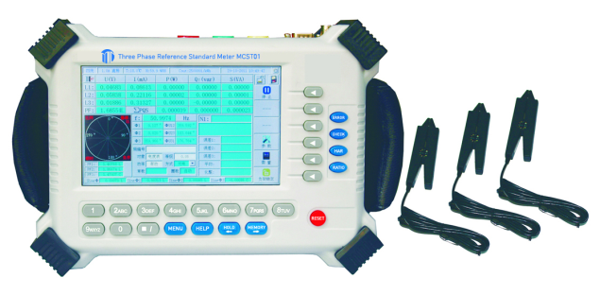

Open the upper cover on the chassis of the instrument, you will see the structure shown in the figure:

1. Power socket
2. Power switch
3. Voltage terminal block
4. Current terminal block
5. Interface of clamp meter
6. Pulse input interface, pulse output interface
7. RS-232, RS-485 serial communication interface
8. USB interface

(10） LCD

(11) Button zone

⑷

（9）

⑶

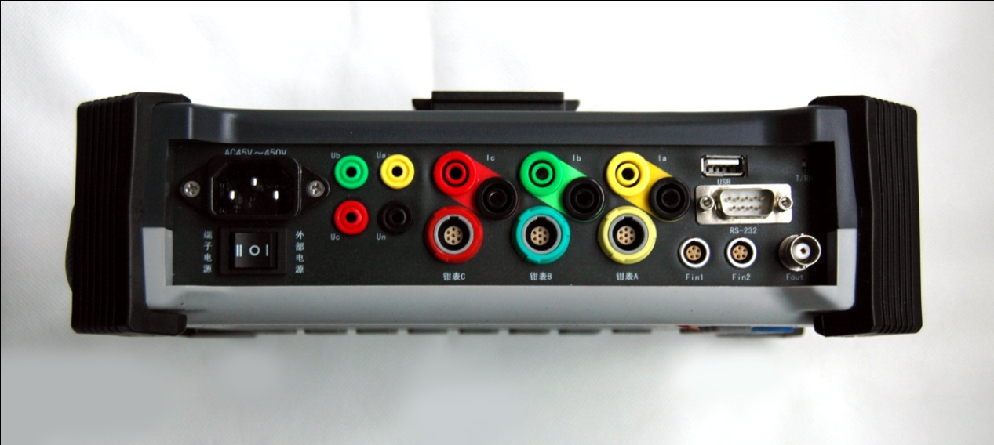

（2）

⑸

⑻

（6）

⑽

（7）

# Chapter VI Wiring

The first step to use the instrument for measurement is how to connect in a correct way. Only when it is connected correctly, can it attain effective test result. If wiring is incorrect, right result will not be available; uninterruptible power test is often conducted on site, so correct wiring should be ensured more, otherwise it may lead to instrument damage. In case of seriousness, it may result in damage of on-site power supply equipment or in hurting the operators causing unnecessary losses. Therefore, right wiring must be conducted according to different test objects on site prior to test.

## 6. 1 Start-up

Prior to wiring, switch on the instrument power first and put the instrument on a smooth working platform, the distance should be 1m or so away from wiring point of tested equipment. Plug directly in ~220V mains interface, in case that there is no ~220V interface on site, power line can be pulled up and gets electricity directly from voltage input terminal, namely, from the low pressure side of voltage transformer. At the moment, it should be noticed whether low voltage output voltage is within the range of 45~450V and be ensured that power consumption of the instrument is within the range of the output power of mutual inductors. When mains interface is used, move the power switch to circumscribed side; when low voltage side of mutual inductor is used, move the switch to the inscribed side. After power on correctly, turn on the power switch, the instrument enters the initial picture shown below, it will enter error calibration interface after about 10s (or main menu, according to instrument setting).

## 6. 2 Voltage Wiring

When voltage signal of calibrated meter is directly accessible to voltage terminal block of instrument panel, attention should be paid that A phase, B phase, C phase and zero line should be right accessible to corresponding terminals.

1. Calibrate single phase meter

Ua is connected to live wire and Un to zero line.

1. Calibrate three-phase three-wire meter (Δ connection method)

Ua terminal and Uc terminal are respectively connected to A phase and C phase voltage. Un terminal is connected to B phase voltage.

1. Calibrate three-phase four-wire meter (Y connection method)

Ua, Ub and Uc are respectively connected to A phase, B phase and C phase voltage. Un is connected to zero line.

0000

**Note: Don’t connect the current signal to voltage terminal, which may lead to secondary circuit opening of mutual inductor and to damage it.**

## 6.3 Current Wiring

（1） Direct Wiring

In the light of current terminal block of instrument panel, A, B, C three-phase current are respectively correctly put in series the calibrated loop.

In the event that secondary circuit of mutual inductor is connected on site, the following sequence should be strictly abided by:

* Connect the A, B, C three-phase current circuit in parallel to both ends of the tested electricity. Notice the positive and negative of polarity.
* Check whether wiring is correct or not, confirm the wiring is firm and there is no possibility to open circuit.
* Disconnect the return circuit of Access Point (AP) to make current get across the instrument, and then conduct test.
* Recover the connection of the braking point after the test.
* Disconnect current test line.

0000

**Note: never add the voltage signal wrongly to the current circuit, which will damage the instrument and on-site equipment. When current is directly accessible, wiring should be conducted in strict accordance with the step above, otherwise it may damage on-site equipment.**

（2） Measurement of Clamp Current Transformer

Connect the three-phase clamp meter plug marked with “A”, “B”, “C” to A, B, C clamp meter interfaces respectively, block the three clamp meters on the three-phase current circuit in the light of A, B, C right phase sequence. At the moment the forward direction and reverse direction should be noticed.

## 6.4 Photoelectricity Sampler

In case of calibrating the electric energy error of the calibrated meter, insert the plug of photoelectricity sampler to the socket marked with “**Fin1”, “Fin2”** on instrument panel, place the photoelectricity sampler in the dead ahead of the calibrated meter which is about between 25~45mm away from the surface of the calibrated meter. Watch the polychromatic light at rear side to determine operating condition:

a. Status light of mechanical meter: Green

b. Status light of electronic meter: Red

c. Status light of hand switch: Orange

Enter status changing by continuously pressing the red reset key for 1.5s. By means of adjusting the up and down positions, beam center is enabled to illuminate on the disk of the calibrated meter or pulse output light of electronic meter. After the status and position are right, photoelectricity sampler will fulfill light sampling automatically with no man regulation.

In the condition of hand switch, active light presents twinkle status. Press the reset key once, a pulse output is triggered.

0000

**Note: in the event of surrounding light change or translocation of photoelectric head leading to falsely triggering or triggering no pulse, just press the red button on the photoelectric head again against the light.**

## 6.5 Power Pulse

If the calibrated meter is one which can trigger pulse or other standard ones, power pulse of the calibrated meter is needed to connect to the instrument. At the moment, the socket of photoelectric head is still used.

# Chapter VII Measurement

After wiring, the instrument can measure different electrical parameters according to various demands of fields or laboratories. It can calibrate three-phase four-wire watt-hour meter, three-phase three-wire watt-hour meter、phase shift 60°vat-hour meter, 90°secondary element overline vat-hour meter, 90°three-element overline vat-hour meter, three-phase four-wire real vat-hour meter, three-phase three-wire real vat-hour meter, artificial central point vat-hour meter and measure voltage, current, phase position, power, power factor, CT variable ratio of every phase as well as ambient temperature, humidity and display vector diagram. It is also able to conduct electric energy measurement, examine the common false wiring of three-phase four-wire watt-hour meter and three-phase three-wire watt-hour meter and calculate the corrected factor and withdrawn electricity quantity of false wiring while conducting harmonic analysis and waveform display and processing meter data and metering data etc.; the chapter will give a detailed account of the specific operating methods of every function.

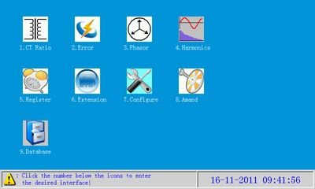

Fig. 7 Main Menu Interface

## 7. 1 Error Calibration (Integrated Measurement)

Turn the instrument on entering activated interface, and enter error calibration interface after about 10s (the initial interface parameter is selected as the interface in the parameter setting of the instrument system), or press the “Error” function key on panel, or click “” icon on the main menu interface or press the numeric key “2” on panel to enter the interface. As shown in Fig. 7.1.

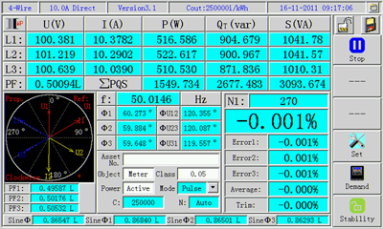

Fig. 7.1 Error Measurement Interface (Monolithic Meter)

By default, system displays current tap position 10A, wiring four-wire. It indicates now that it has been in normal operating state. Real-time measure three-phase voltage, current, phase position, vector diagram, frequency, power factor and degree of distortion etc.

The top on the interface is status indication column displaying instrument’s wiring method, current tap position indication, version number, output constant of the instrument, system time and main menu icons etc. Indication of different interface status columns is identical (except main menu interface, other menu interfaces).

The bottom left of status indication column displays metering contents such as voltage, current, power, power factor, frequency, error, degree of distortion and vector diagram etc.

The right of the interface is six menu keys which are respectively in different interfaces having various functions. From top to bottom below respectively is called menu key 1~6 for short which are separately corresponding to six arrow keys on interface.

**Function of menu keys on the interface:**

 ：Control start and stop of error calibration. “Stop” indicates in start status of error calibration, “Start” indicates in stop status of error calibration;

 :Inoperative;

 :Inoperative;

 :Press the key entering user parameter setting interface;

 :Inoperative;

 :Press the key entering test interface requiring measuring;

：Indicating instrument is in the mode of load stability. Users can set the mode according to actual load condition. Press the key to hand over between “Stability”, “Instability” back and forth. In normal condition it is set as “Stability”. When load sharply fluctuates in large range (bounce>10%), it is needed to set as “Instability”.

0000 **Note: “- - - ” indicates ineffectiveness; click the menu key icon on the screen having the same function as pressing the keys on the corresponding panel of the icon!**

**Implication of electrical parameter on interface**

L1：A phase

L2：B phase

L3：C phase

U（V）：voltage，unit：V

Ⅰ（mA）（or A）：current, unit: mA（or A）(when the max. current among three phases ≥0.5A, it automatically jumps to be A; when ≥0.5A, it automatically jumps to be mA).

P（W）：Active power, unit: W

QT（var）: Reactive power, unit: var

S（VA）：Apparent power, unit: VA

PF：Total power factor

ΣPQS：Indicates total active power, total reactive power, total apparent power

PF1：A phase power factor

PF2：B phase power factor

PF3：C phase power factor

f: frequency

N1（T1）：pulse number (number of turns), when “Error Interval” item on “System Parameter” interface of the instrument is selected as “Pulse Number”, it displays “N”; when selected as “Time Progress Bar”, it displays “T”; when selected as “N”, during error calibration, the numbers on the right will gradually decrease, when decreased to ‘0’, error will update. When selected as “T”, during error calibration, the blue bar on the progress bar frame of “T” on the right will gradually move towards the right, when moving to the tail, error will update. The figures ‘1’, ‘2’ behind the character “N” or “T” are separately corresponding to “Fin1”, “Fin2”photoelectrical head input sockets.

**For four-wire:**

Ф1：A phase power factor angle (phase position between Ua and Ia)

Ф2：B phase power factor angle (phase position between Ub and Ib)

Ф3：C phase power factor angle (phase position between Uc and Ic)

ФU12：phase position between A phase voltage and B phase voltage

ФU23：phase position between B phase voltage and C phase voltage

ФU31：phase position between C phase voltage and A phase voltage

**For three-wire:**

ФU12I1：A phase power factor angle (phase position between Uab and Ia)

ФU32I3：C phase power factor angle (phase position between Ucb and Ic)

ФU12U32：phase position between A phase voltage and C phase voltage (phase position between Uab and Ucb)

At the below of phase position display zone are some simple data of users and some parameters as error calibration. In addition, parameters required by error calibration can be directly modified and set on the interface.

0000**Note: “QT” indicates real reactive power, “QJ” indicates overline reactive power; when current clamp over 1000A is selected, the unit of active power is changed to “KW”, that of reactive power to “kvar”, that of apparent power to “kVA”. The character “L” behind the numerical value of total power factor represents lagging induction; “C” represents lead capacity. When “4-wire” status is shifted to be “Three-wire’ status, B phase of the instrument has no test data. “L2” is changed to be “- - -”, data display zone on the right is changed to be “- - - - - -”, “PF2” to be “- - -”, data display zone on the right is changed to be “- - - - - -”, characters “U2” and “I2” in harmonic distortion degree zone are separately changed to be blank, and its data is changed to be “- - -”.**

**When monolithic electric energy meter is calibrated, please plug the photoelectrical head in the mouth of “Fin1”.**

## 7.2 Input Methods of Letters, Chinese Characters (spelling) and Symbols

**Letters:** in user parameter input zone, when cursor is in instrument number or instrument name or user unit input frame, press menu key 5 to shift to “”, press numeric keys 2~9, at the moment character input zone will list the capital and lower case letters of corresponding numeric keys, for example, input the letter “A”, press the numeric key “2”, screen is shown as Fig. 7.2.1. Then press menu key 3“”, figures will appear in front of letters (as shown in Fig. 7.2.2). Choose the required letter according to the figures in front of letters, for instance, choose “4” and the letter “A” will appear in the parameter input zone.

**Symbol**: press menu key 5 to shift to “”, symbols will appear in character zone as shown in Fig. 7.2.6. Press “🡆”key or “🡄” on panel to find out symbol required, just choose in the light of the numeric keys in front of the required symbols. At the moment the chosen symbols will appear in parameter input frame activated by cursor.

**Figures**: press menu key 5 to shift to “”, just directly press numeric keys on panel inputting.

Alpha Fig. 7.2.1

AlphaOk

Fig. 7.2.2

Pinyin

Fig. 7.2.3

Pinyin1

Fig. 7.2.4

## 7. 3 Parameters Setting

Press menu key 4“” key, instrument enters calibrated meter parameter setting interface, at the same time the menu keys at the right side are changed successively to: “” “” “” “” “” “”，as shown in Fig. 7.3.1.

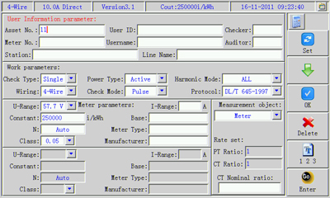

Fig. 7.3.1

Here you can directly input parameters, or call in them from the table. Input Asset No. in the “Asset No.” parameter frame, then press the key “”, in case of relevant parameters now having been stored in the instrument, call in parameters directly from the table.

**7.3 Parameter Setting of Calibrated Meter**

The pictures are used for the setting of calibrated meter parameter separately setting different parameters. Calibrated meter parameter can be either directly input on site or directly shift the pre-stored calibrated meter parameters.

**Functions of icons of menu keys are as follows under the interface:**

 ：Choose parameter input zone;

 ： Move cursor to the parameter item requiring setting or inputting;

 ：Pop multiterm parameter menus or determine (close parameter menu) the selection parameter item;

 ： Delete wrong input characters;

 ：Switch input method and switch among “Figure”, “Letter”, “Spelling” and “Symbol” in turn.

：Confirm parameter input, and return to the original function interface.

In parameter input zone, some parameter items can only input figures and some can not input Chinese characters. Parameter items with down arrow are selected ones. Specific operating methods are: move the cursor to the parameter item (or directly click the input frame of the parameter item), press menu key 3 (or click “x1.bmp”), at the moment screen will pop parameter window and menu key 3 is changed to “OK”. Listed in the parameter window are all selected parameters. Press menu key 2 moving cursor to the parameter to be selected (or directly click the parameter), then press menu key 3 (or click “x1.bmp” icon), parameter window will disappear. At the moment the input frame of the parameter item will display the just selected parameter.

Initial status system displays default parameters. Parameter setting is as follows:

**User Information Parameter Zone:**

* Asset No.: it means unit number the calibrated meter belongs to; the parameters of the item may be figures, letters and symbols, 18 characters can be input in all;
* Meter No.: it means factory number of the calibrated meter; the parameters of the item may be figures, letters and symbols, 18 characters can be input in all;
* User ID: number of user. the parameters of the item may be figures, letters and symbols, 18 characters can be input in all;
* Username: name of the metering user. The item may be figures, letters, Chinese characters or symbols and 24 characters can be input in all. A Chinese character amounts to two characters;
* Checker: input name (or number) of the checker. 8 characters can be input. The parameters of the item may be figures, letters, Chinese characters or symbols;
* Auditor: input name (or number) of the auditor. 8 characters can be input. The parameters of the item may be figures, letters, Chinese characters or symbols;
* Station: the name of transformer substation affiliating the metering equipment. 30 characters can be input. The parameters of the item may be figures, letters, Chinese characters or symbols;
* Line Name: the name of circuit affiliating the metering equipment. 30 characters can be input. The parameters of the item may be figures, letters, Chinese characters or symbols;

**Method**: press menu key 1” ” to choose the area to be activated, at the moment the characters “User Information Parameter” in the area gets red. Move cursor to the parameter item requiring inputting, press numeric keys “1～9” and coordinate with menu keys inputting figures, letters, Chinese characters or symbols required.

**Working Parameter Zone of Calibrated Meter:**

* Check Type: the type of setting calibrated meter. The parameters may be selected parameter items. There are 3 sorts of parameters for selection: “Single”, “multi.”, “M+S”;

“Single”: only check error of a meter.

“Multi.”: able to check simultaneously active and reactive power errors of multi-functional meter, or check the error of a watt-hour meter and a vat-hour meter at the same time.

“M+S”: check errors of two meters simultaneously, and the two meters are the same type.

* Wiring: set the wiring of the instrument. There are 2 parameters for selection---“4-wire” and “3-wire”. It is set in accordance with the wiring of the checked electric energy meter. If the meter is single-phase, “4-wire” is selected; when the meter is three-phase four-wire wiring (Y wiring), “4-wire” is selected; when the meter is three-phase three-wire wiring (Δ wiring), “3-wire” is selected.
* Power Type: set according to the type of the calibrated meter. When the checked meter is three-phase four-wire wiring, there are 4 parameters for selection: “Active, “Qn” “Q90” (three-element Q90 overline reactive) and”Aprrent”; when three-phase three-wire, there are 5 sorts of parameters for selection: “Active, “Qn”, “Q60” (phase shift 60°reactive, central point reactive) ,“Q90” (two-element Q90 reactive) and”Aprrent”. When the calibrated meter is active type, the parameter will be selected as “Active”; when reactive type, selected as “Qn”. Reactive types can be selected according to the selection of reactive types for the calibrated meter. When check type is “multi.”, the parameter item cannot be set. The color of input frame turns grey.
* Check Mode: there are 2 parameters for selection—“Pulse” and “Manual”. When photoelectric head or electrical pulse line is used to collect electric energy pulse (or number of revolutions) of calibrated meter, it is set as “Pulse”; when hand switch is used, selected as “Manual”.
* Harmonic Mode: there are 2 parameters for selection—“All” and “fundamental”. When it is selected as “All”, it indicates electric energy test on full wave (including harmonic wave); when selected as “fundamental”, it shows electric energy test on fundamental wave.
* Protocol: it means the one when the calibrated meter has RS-485 opening. The parameter item can be expanded and at present only supports DL/T 645-1997.

All parameter items in the parameter zone are selected. Press menu key 1 “”to activate the parameter zone, at the moment the characters “Work Parameters” get red. Press menu keys 2 “”and 3 “”to coordinate for operation. Just choose the required parameters.

**Calibrated Meter Information Parameter Zone 1:**

● U-Range: it means voltage range of the calibrated meter. There are 4 parameters for selection in all: “57.7V”, “100V”, “220V”, “380V”；

● I-Range: it means current range of the checked meter. 6 characters can be input. The parameters of the item can only input figures;

● Constant: refers to electric energy constant of the checked electric energy meter. 10 characters can be input. The parameters of the item can only input figures. Unit of constant will vary with the setting of parameter items according to “Power Type” in work mode zone. When power type is “active”, unit of constant is “i/kWh” indicating error of the checked watt-hour meter; when power type is other parameter, unit of constant is “i/kvar” indicating error of the checked vat-hour meter.

● N: sets how many input pulses (or number of revolutions) in an error calculation. 6 integers can be input. The parameters of the item can only be input figures and they must be integers. When parameter is “0”, number of pulses displays “Auto”.

● Class: means accuracy class of the checked meter. There are 8 parameters for selection in all: “0.05, 0.1, 0.2, 0.5, 1.0, 2.0, 0.2S, 0.5S”.

● Base: used for reading the current electric energy indicating value of the electric energy meter. 10 characters can be input. The parameters of the item can only input figures.

● Meter Type: refers to the type of the checked meter. 16 characters can be input. The parameters of the item can not input Chinese characters.

● Manufacturer: refers to manufacturer name of the checked meter. 16 characters can be input. A Chinese character amounts to 2 characters.

When “Check Type” is selected as “Single” in work mode zone, the background color of the parameter input frame in Meter Information Zone 2 turns grey. Meanwhile, the name of the parameter zone disappears. At the moment only Meter Parameter Zone 1 can be activated.

When “Check Type” is selected as “Multi.”, it indicates error checking a watt-hour meter and a vat-hour meter simultaneously, or error checking active and reactive electric energy of a multi-functional meter simultaneously. Meter parameter zone 1 now displays “Active Parameter”; parameter zone 2 displays “Reactive Parameter”, parameter input frame gets white. The unit of the meter constant in parameter zone 1 now is “i/kWh” while that of constant in parameter zone 2 is “i/kvar”. Parameter items in parameter zone 2 are the same as those in parameter zone 1. And their input methods are identical.

When “Check Type” is selected as “M+S”, it indicates error checking two watt-hour meters and two vat-hour meters simultaneously. Meter parameter zone 1 now displays “Master Parameter”; parameter zone 2 displays “Slave Parameter”, parameter input frame gets white. Now the unit of the meter constant in meter parameter zone 1 and 2 is identical. Meanwhile, it displays “i/kWh” or “i/kvar”. The parameter items in in meter parameter zone 1 and 2 are the same, and their input methods are identical.

**Measurement Object Zone:**

* Measurement Object: select object to be tested: meter or metering device (including electric energy meter, PT or CT variable ratio). There are 2 parameters for selection: “Meter” and “Device”;
* PT Ratio: refers to the ratio of voltage transformer across by voltage input of the checked meter. Input when the measurement object is “Metering Device Composite Error”. Input 10 characters and separate primary voltage from secondary voltage by “/” (press the key “./” on panel). For example: primary side voltage of transformer is 10KV, secondary side voltage is 100V, just input “10000/100”.

When measurement object is a “Meter Error”, system default is “1”.

* CT Ratio: refers to the ratio of current transformer across by current input of the checked meter. Input when the measurement object is “Device”. Input 10 characters and separate primary current from secondary current by “/” (press the key “./” on panel). For example: primary side voltage of mutual inductor is 1000A, secondary side voltage is 5A, just input “1000/5”.

When measurement object is a “Meter”, system default is “1”.

* CT Nominal ratio: useful when measuring CT variable ratio, it indicates nominal ratio on CT nameplate. Input methods are the same as those of CT ratio.

0000 Note：It also can be operated by touch screen. When inputting a certain parameter, directly click the input frame of the parameter, automatically activate the zone the parameter item is located at, cursor will automatically move to the input frame of the parameter item. Click the upper right corner “Key.bmp” of the display screen, on the screen will appear software disks as shown in the figure below. Its functions are the same as those of the corresponding numeric keys on panel. Click the button “Delete” on soft keyboard to delete the input wrong characters. Click the upper right corner “Close.bmp” of the soft keyboard to close the keyboard. For parameter frame for selection, directly click the right side button “x1.bmp” of the parameter frame. At the moment on the screen will pop parameter window, directly click the parameters in the window, then click the button “x1.bmp” again, parameter window is closed. Now the just selected parameter will appear in the parameter frame.

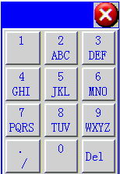

## 7.4 Error Checking Measurement Interface

Real-time measurement voltage, current, split-phase active power, split-phase reactive power, split-phase apparent power, total active power, total reactive power, frequency, phase position, total power factor, split-phase power factor and error etc, should refresh new vector diagrams in the light of measured data in the mode of monolithic error measurement.

### 7.4.1 Monolithic Meter Error Calibration

When “Check Type” is selected as “Single” in parameter work mode zone, display interface is as shown in Fig. 7.1.

When calibrating monolithic meter, please insert the photoelectric head into the port of “Fin1”.

Some important parameters for calibrating meter are displayed in user parameter display zone of the interface, which are used for reference when users calibrate meter. White parameter frames are unchangeable parameter items and other colors are changeable ones. 3 calibration parameter items thereinto can be directly modified in the interface such as mode, constant and number of turns. Operational methods are as follows:

Press menu key 1 (or click ), 6 menus change into in turn , ,  , ,  , , cursor now appear in the former parameter input frame. In addition, menu key is changed to what is shown below. The original “unlock.bmp” icon on the upper right side on screen is changed to “Key.bmp”. Input parameter items requiring modifying according to the introduced methods in parameter setting.

After parameters are modified, press menu key 1 (or click icon ）to recheck error. Menu key reverts to the original state.

0000 **Note：click Key.bmpicon, soft keyboard as shown below will appear, click input parameter on soft keyboard; directly click parameter frame, cursor automatically jumps to the parameter frame. Click Close.bmpicon to close the soft keyboard.**

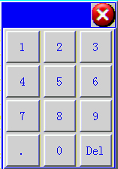

### 7.4.2 Main and Auxiliary Meters Error Calibration (The error of two meters in identical type is calibrated simultaneously)

When check type item in parameter calibration mode zone is selected as “M+S”, shown as the interface in the following picture below.

When main and auxiliary meters (two meter in identical type) are calibrated, insert the electric energy pulse of the major meter into the port “Fin1” of the panel and that of auxiliary meter into the port “Fin2” of the panel.

The interface will not display vector diagram but the error of the two meters simultaneously.

In the interface, several important parameters displayed in user parameter zone are for user reference. White parameter frames are unchangeable while other colors are changeable.

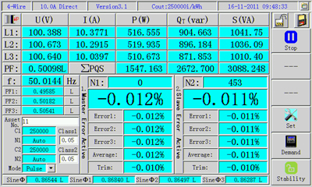

Fig. 7.4.2 Main and Auxiliary Meter Calibration Interface

The implication of parameters is as follows:

Asset No.：Parameter items set in parameter setting;

C1：Constant of major electric energy meter;

N1：Number of turns (or number of pulses) set for major electric energy meter calibration;

C2：Constant of auxiliary electric energy meter;

N2：Number of turns (or number of pulses) set for auxiliary electric energy meter calibration;

Mode：Parameter items of calibration modes in the same parameter setting interface;

Class1：Accuracy class of main electric energy meter;

Class2：Accuracy class of auxiliary electric energy meter;

Pursuant to the test condition of error calibrated on site, the error parameter items can be modified directly in the interface. For specific methods, refer to the methods introduced for monolithic meter error calibration.

### 7.4.3 Multi-function Meter Error calibration (Active and Reactive Error are Calibrated Simultaneously)

When calibration type option in parameter calibration mode zone is selected as “Multi.”, its interface is basically same with that of main and auxiliary meters calibration. The difference is: the display is changed that main meter error data zone displays watt-hour meter error data and auxiliary meter error data zone display vat-hour meter error data.

When checking multi-function meter (or a watt-hour meter and a vat-hour meter), insert the electric energy pulse of the watt-hour meter into “Fin1” port of the panel, and that of vat-hour meter into “Fin2” port of the panel.

The implication of parameters is as follows:

Asset No.：Parameter items set in parameter setting;

C1： Constant of watt-hour meter;

N1：Number of turns (or number of pulses) set for watt-hour meter calibration;

C2：Constant of vat-hour meter;

N2：Number of turns (or number of pulses) set for vat-hour meter calibration;

Mode: Parameter items of calibration modes in parameter setting interface;

Class1：Accuracy class of watt-hour meter;

Class2：Accuracy class of vat-hour meter;

Pursuant to test condition of error calibrated on site, the error parameter items can be modified directly in the interface. For specific methods, refer to the methods introduced for monolithic meter error calibration.

0000Note：Press “Hold” key on panel in error calibration interface to freeze measurement data. Now data will not refresh. The upper left icon on menu key is changed to “D:\lock.bmp”；press “Hold” key again, data now is unlocked and getting refresh and change. The upper left icon on menu key is changed to “D:\unlock.bmp”；directly click “D:\unlock.bmp”or “D:\lock.bmp” icon having the same function as the “Hold” key on panel.

Press “Storage” key on panel or click “D:\SQ-2008S\save.bmp”icon at upper right corner on menu key to store relevant data of the interface.

### Demand Measurement

Under error test interface, press “”，into demand measurement interface as below Fig 7.4.4：

Two kind of test method namely “interval method” and “slip method” for choice in system setting。

Input demand intervals (range 1-60min); then press“” to start the measurement， after test finished (or you can press “” to make the test finish)， input “demand indication value” , meanwhile, standard value & indication error value will be displayed.

Demand Indication Meter： demand indication value of meter under test during the interval of demand.

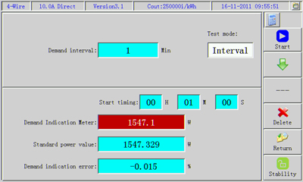

Fig. 7.4.4 Demand Measurement Interface

## 7.5 Phase Measurement, Wiring Check, Electric Quantity Compensation

Press “Check” function key on panel to enter the measurement interface as shown in the figure below. On the measurement interface will display vector diagram among all roads of signals and measure the phase between voltage and current, between voltage and voltage. Voltage and current amplitude; finding results, voltage degree of asymmetry, current degree of asymmetry, angle error value of power factor among all roads; corrective steps, corrective factors, power expression, corrective factor formula, wiring diagram and electric quantity compensation etc are also given in wrong wiring.

The three-phase four-wire mode slightly differs from three-phase three-wire mode in the interface.

When “Wiring Mode” item among parameters is “4-wire”, the function interface entering primarily is as following figure.

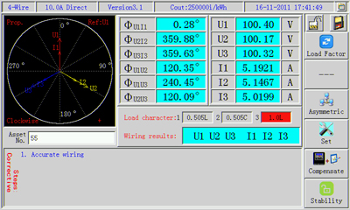

**Functions of Menu Keys:**

: When checking lines, change over load property according to on-site load to get right result;

 ：The key does not work under the mode of three-phase four-wire;

：The interface is used for changing over measurement function item. It can be changed over in turn among “line inspection”, “asymmetry” and “phase difference”;

： Enter the interface to set user parameter;

 ：Used for changing over the interfaces of vector diagram and electric quantity compensation interface;

 ： To change over load stability, the function is same as that of error measurement interface.

The implication of all characters and data in the interface is as follows:

**Vector Diagram Zone:**

1. Prop. display (or fixed length display): Prop.: when vector diagram is drawn, the vector length will vary with signal amplitude; Fixed: when vector diagram is drawn, the vector length is unchangeable, in no relation with signal amplitude (the parameter can be set in the instrument setting interface);
2. Clockwise (or Anticlockwise): rotary direction of vector diagram, clockwise or Anticlockwise ( the parameter can be set in the instrument setting interface);
3. Ref: reference signal for drawing vector diagram, U1 (A-phase voltage) or I1（A-phase current） (the parameter can be set in the instrument setting interface);
4. + (or -): the current phase sequence for wiring.

“3-Wire”:When pressing menu key 2 to select “Normal Vector”, instrument draws vector diagram according to the tested data result. When menu key 2 is selected as “Wiring Vector”, instrument draws the actual vector diagram of the false wiring.

**Phase Display Zone:**

When instrument is in three-phase four-wire mode (Y connection method), screen display interface is as shown in the figure.

The implication of the contents in the area is as follows:

ФUaIa: phase between A-phase voltage (phase voltage) and current;

ФUbIb: phase between B-phase voltage (phase voltage) and current;

ФUcIa: phase between C-phase voltage (phase voltage) and current;

ФUaUb: phase between A-phase voltage and B-phase voltage (phase voltage);

ФUaUc: phase between A-phase voltage and C-phase voltage (phase voltage);

ФUbUc: phase between B-phase voltage and C-phase voltage (phase voltage);

When instrument is in three-phase four-wire mode (Δ connection method), screen display interface is as shown in the figure.

The implication of the contents in the area is as follows:

ФUabIa: phase between A-phase voltage (line voltage) and A-phase current;

ФUabIc: phase between A-phase voltage (line voltage) and C-phase current;

ФUcbIa: phase between C-phase voltage (line voltage) and A-phase current;

ФUcbIc: phase between C-phase voltage (line voltage) and C-phase current;

ФUabUcb: phase between A-phase voltage and C-phase voltage (line voltage);

ФIaIc: phase between A-phase current and C-phase current.

**Signal Amplitude Zone:**

When instrument is in three-phase four-wire mode (Y connection method), screen display interface is as shown in the figure.

Ua: A-phase voltage data (phase voltage);

Ub: B-phase voltage data (phase voltage);

Uc: C-phase voltage data (phase voltage);

Ia: A-phase current data;

Ib: B-phase current data;

Ic: C-phase current data;

When instrument is in three-phase four-wire mode (Δ connection method), screen display interface is as shown in the figure. The interface instrument B-phase has no test data.

At this time, the implication of the displayed in the area is as follows:

Uab: A-phase voltage data (line voltage);

Ucb: C-phase voltage data (line voltage);

Ia: A-phase current data;

Ic: C-phase current data;

### 7.5.1 Wiring Check

Function of inspecting lines is a major weapon for on-site calibration. It is able to accurately find out the common false wiring of three-phase four-wire in 96 sorts and three-phase three-wire in 48 sorts (totally 144 sorts), to provide accurate basis for exercising measurement supervision and put an end to electric energy loss caused by intended or unintentional false wiring.

**Basic Requirements for Inspecting Lines:**

Inspecting lines is a logical reasoning process that must meet a certain condition to acquire a correct result. If failing in meeting these basic conditions, false result may be obtained. Therefore, before using the function of inspecting lines, you should confirm whether the object to be checked meets the following conditions:

● The connection mode of checked meter is the same as that of this instrument;

● Voltage and current amplitude are not less than 5% of current range of the instrument;

● The error of voltage and current three-phase symmetry is not more than ±15°.

● The approximate deviation of on-site power factor should be known, namely induction, capacity or neutrality after compensation;

● Confirm the instrument itself has no false wiring;

● Vector diagram has refreshed at least one time;

● Phenomenon of phase failure does not take place;

● When actual on-site load power factor is equal to 0.5, the line-inspecting result may be false.

Methods for inspecting lines:

First, in the light of the wiring mode of calibrated meter and after confirming the instrument itself has no false wiring, and according to the property of actual on-site load power element, press menu key 1 “Load Property” key and choose the load property as inspecting wiring. There are 3 options in “Load Property” prompt zone on screen: 1：0.505L (induction); 2：0.505C（capacity）; 3：1.0L (neutrality). Red background is the currently chosen load condition. After selecting the load property, the current result of inspecting lines will display at the place on screen.

Assume the result display: Ua Ub Uc +Ia+Ic

It shows three-phase voltage sequence is: UaUbUc;

Current : +Ia +Ic: of which +current direction is positive.

When the result displays “Uncertain”, it shows failure in finding out correct result of inspecting lines.

When menu key 3“”, the correction steps of false wiring will be given at the lower of screen. Users may refer to the steps to correct false wiring.

### 7.5.2 Asymmetry Measurement

In the interface of vector diagram display, press menu key 3 to select “”, then the instrument enters the measurement interface of voltage and current asymmetry. The relevant data tested will be displayed at the lower of screen .

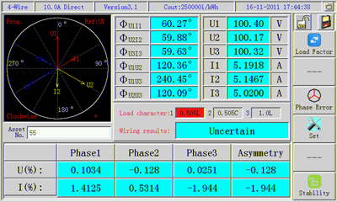

Fig. 7.5.2 Measurement Interface for Voltage and Current Asymmetry

### 7.5.3 Measurement of Phase Asymmetry

In the display interface of vector diagram, press menu key 3 to select “”, then the instrument enters the measurement interface of phase asymmetry (namely D-value of three-phase power factor angle). Below the screen will display the relevant data tested.

### 7.5.4 Electric Quantity Compensation

In the display interface of vector diagram, press the menu key “”, then the instrument enters the measurement interface of electric quantity compensation. Interfaces of instrument vary with the mode of connection. In three-phase four-wire state, users can read the kilowatt-hour number displayed on electric energy meter. After users input CT multiplying power (ratio), CT multiplying power and the actual average power factor of current load, the instrument automatically calculates the corrective factor and the compensated electric quantity in the false wiring condition. In three-phase three-wire state, in addition to the function above, it also gives power expression of split-phase in false wiring, conjunction power expression and corrective factor expression. After inputting relevant parameters, press menu key 1 “”, the instrument automatically calculates corrective factor and compensated electric quantity.

**Operating Methods:**

First enter the interface, the instrument enters input parameter state, menu key 1 is “” input state, press menu key 1 to change over in turn between input parameter state and calculation state. When menu key 1 is “”, it is now parameter input state, the parameter frame input gets red. Press menu key “” and move cursor to the parameter item to be input, after pressing numeric key and menu key 3 “” to input relevant parameters, press menu key 1 “”, menu key 1 now turns to “”, enter calculation state. Instrument automatically calculates corrective factor and compensated electric quantity.

Press menu key 5 “” to return to the interface of line inspection and of vector diagram.

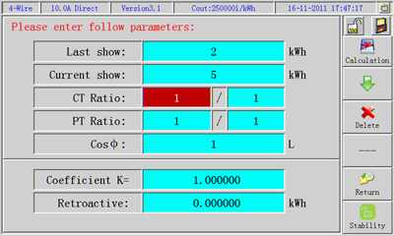

Fig. 7.5.4 The Interface for Three-phase Four-wire Compensated Electric Quantity

0000Note：press “Hold” key on panel in vector diagram interface to freeze measurement data. Now data will not refresh, the icon on the upper left corner on the menu key turns to “D:\lock.bmp”; press “Hold” key again, now data are unlocked and are refreshing and changing. The icon on the upper left corner on the menu key turns to “D:\unlock.bmp”; directly click “D:\unlock.bmp”or “D:\lock.bmp” icon having the same function as “Hold” key on panel.

Press “Storage” key on panel or click “D:\SQ-2008S\save.bmp” icon on the upper right corner on menu key to store relevant data of the interface.

## Harmonic Analysis

Press “Har” keypress on faceplate or press numeric keypress “4” under main menu or click “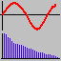” into harmonic analysis function interface, as chart 7.6

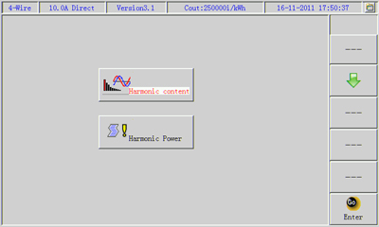

Chart 7.6

Then you can see two functions menus：

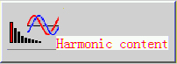： can do the test of harmonic content, harmonic amplitude and harmonic phase, also display waveform；

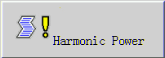： can do the test of harmonic active power, harmonic reactive power, harmonic apparent。

* + 1. **Content, amplitude and phase of harmonic; waveform display**

In above interface “chart 7.6” ， press“”, select “”，then press

“” into below chart 7.6.1 interface。

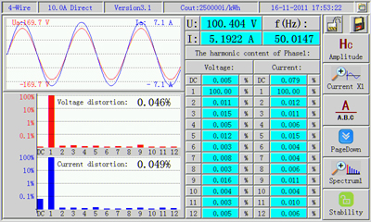

Chart 7.6.1

The interface may display inphase voltage and current waveform; voltage amplitude, current amplitude, frequency; column diagram of voltage harmonics, column diagram of current harmonics, degree of voltage distortion, degree of current distortion; harmonic contents of voltage and current every time, harmonic amplitude, harmonic phase etc. Besides, current waveform and harmonic column diagram have amplification function. The amplification coefficient of current waveform can be chosen among “X1”, “X2”, ”X4”, “X8”, “X16” and “X32”; amplification coefficient of column diagram can be selected among “X1”, “X5”, “X10”, “X20”, “X100”, “X200”, “X1000” so that users observe relevant data.

**Functions of Menu Keys:**

 ： Change over harmonic data type and change in turn among “Content”, “Amplitude” and “Phase”. Besides, relevant data on screen will also vary with them.

 ：Change over amplification coefficient of current waveform and choose among “X1”, “X5”, “X8”, “X16” and “X32”.

 ： Change over the tested data phases—A-phase, B-phase or C-phase; when wiring mode is three-wire, there are no B-phase data;

 ：Change over the sequence of harmonic waves;

 ：Change over coefficient of harmonic column diagram and choose among “X1”, “X5”, “X10”, “X20”, “X100”, “X200”, “X1000”;

 ：Change over the state of load stability, and the function is same as that of error measurement interface.

0000N*ote：press “Hold” key on panel in interface to freeze measurement data. Now data will not refresh, the icon on the upper left corner on the menu key turns to “D:\lock.bmp”; press “Hold” key again, now data are unlocked and are refreshing and changing. The icon on the upper left corner on the menu key turns to “D:\unlock.bmp”; directly click “D:\unlock.bmp”or “D:\lock.bmp” icon having the same function as “Hold” key on panel.*

*Press “Storage” key on panel or click “D:\SQ-2008S\save.bmp” icon on the upper right corner on menu key to store relevant data of the interface. Waveform data cannot be stored but other data can be stored at one time.*

***Click icon on menu key, having the same functions as the menu keys on panel***.

**7.6.2 Test of harmonic power**

In above interface “chart 7.6”， press “”, select “”，then press

“” into below interface chart 7.6.2

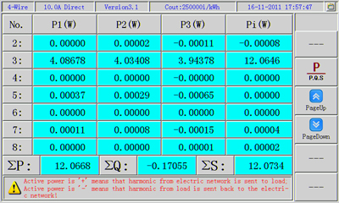

Chart 7.6.2

Under this interface, can test active&reactive&apparent power of every time harmonic; can test total active & total reactive & total apparent power of every time harmonic; can test total active&reactive&apparent power of harmonics

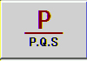： can select & test active & reactive & apparent power of harmonics by pressing this keypress；

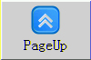： decrease successively pages quantity of harmonic times by pressing this keypress；

：Increase successively pages quantity of harmonic times by pressing this keypress。

## 7.7 CT Variable Ratio Test

Press the function key “Ratio” on panel, or in the interface of the main menu, press numeric key “1” on panel or directly click icon “” to enter the interface of the function as shown in Fig. 7.7. In the interface primary current of CT per phase, secondary current, ratio, ratio error, angle error and polarity can be measured. Measurement method is primary side with C phase clamp, secondary side current with A current input (i.e. clamp or direct input is applicable).

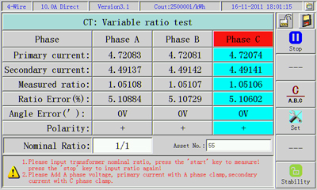

Fig. 7.7 Interface of CT Variable Ratio Measurement

Prior to measuring variable ratio, first input nominal ratio on CT nameplate, the parameter may be imported directly from the prestored asset number record, otherwise CT ratio error can not be measured.

**Functions of Menu Keys:**

 ：Press the key to input nominal variable ratio again; press again to recalculate;

 ：Invalid key;

 ： Change over phases;

： Enter parameter setting interface;

 ：Inoperative;

：Function is identical to that of error measurement interface.

Press menu key “”, and connect primary clamp and secondary clamp to the corresponding phases of CT in turn, relevant CT data of A phase, B phase or C phase can be measured in turn.

0000 ***Note：as measurement is made in the interface, add voltage signal to voltage input terminal A phase of the instrument, otherwise it is failed to measure angle error of CT correctly!***

**7.8 Counter Test (Watt-hour meter Test), Electric Energy Measurement, Calibration Constant**

In the screen of main menu, press number key 5 or directly click “” can enter into the interface as shown in Fig. 7.8.

Electric energy measurement, watt-hour meter counting device test and electric energy meter calibration constant and other tests can be conducted in this functional interface.

The function of menu key：

 ：Press this key to start to accumulate electric energy after the inputting of relevant parameters;

 ：Move cursor to inputting parameter box when electric energy stops the state of accumulating;

 ： Changing-over of accumulative method, electrical degree value or time method of electric energy;

 ： Enter users’ parameter setting interface;

 ： Delete the inputted false interface;

 ： Function is same as that of error measurement interface

There are two accumulative methods for electric energy:

First method: “Energy value” method: set the electrical degree value to be accumulated, the instrument will stop accumulating when the measured electric energy value is bigger than the set electric energy value.

Second method: “Time” method: set the electric energy time to be accumulated, stop accumulating when the time is out.

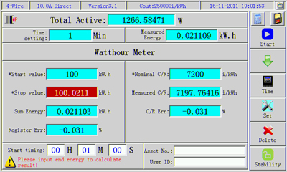

Fig. 7. 8

**Operational Approach:**

First input setting time or setting electric energy value, initial reading of initial reading, calibration constant as per the selected approach before electric energy test, and then press button 1 “”, and the electric energy test will begin when menu key 1 is changed to “”. The menu key will change to “” and electric energy test will not be conducted lacking of input of relevant parameter. If the measured electric energy value ≥setting electric energy value, or the setting time is out, electric energy accumulation will be stopped, then the cursor will automatically stop at terminate readings parameter dialog box, then input the reading of electric energy meter immediately. Then display difference, register error, measured constant and constant error will be computed by the instrument immediately.

If the verification mode in users’ parameter is set as “multi.”, active 、reactive and aprrent energy accumulation can be conducted at the same time; watt-hour meter test, calibration constant can be conducted for active energy meter and reactive energy meter at the same time.

If the verification mode in users’ parameter is set as “M+S”, watt-hour meter test and calibration constant can be conducted for two electric energy meter of the same type at the same time.

## 7.9 Extended Function

In the surface of main menu, press number key 6 or click “” can enter into extended function interface, which is shown as follows:

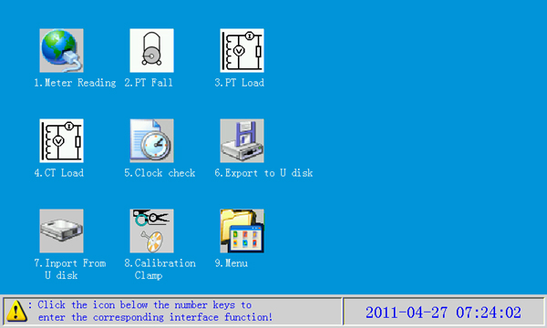

Fig. 7.9 Extended Function Menu

### 7.9.1 Automatic Meter Reading

Pursuant to the requirements of *Instruction for Electric Energy Measuring Equipment On-site Operation* issued by Sales Department of State Grid Corporation of China in July 2005, the following functions are added to this function to meet the working requirements of multifunction electric energy meter on-site checkout：

1. Check of decompression record of electric energy meter;
2. Check of internal battery of electric energy meter;
3. Check whether the sum of electrical energy at each rate is equal to total electricity;
4. Check whether the internal calendar clock of electric energy meter is correct.
5. Check whether the setting in rate time interval is correct;
6. Check the frequency and the time of the latest programming of the electric energy meter;
7. Check whether the setting of maximum demand register is correct;
8. Check whether the account day of rate electric energy meter is correct.

This function is only applicable to multifunction electric energy meter of DL/T 645-1997 communication protocol.

**Operational Approach:**

1. Insert RS485 communication line into instrument serial communication socket, then connect it to 485 communication line of multifunction meter.
2. In the interface of main menu, press number key 6 or click “” to enter into other function menu interface.
3. In the interface of other function, press number key 1 or click “” to enter into interface of this function.
4. Press menu key 5 to select function;
5. Press menu key 5 to select baud rate;
6. Press menu key 1 to start read relevant data of multifunction meter.

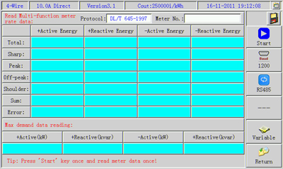

### 7.9.2 Import Data from U Disk

This instrument can not only receive parameter information of electricity meter planned to be checked from communication port, but also can import parameter information of the checked meter from U disk. The operational procedures are as follows:

Insert the U disk into U port of upper PC computer

Upper PC softaere imports information of electric energy mater planned to be checked into U disk.

U disk inserts into MCST01 USB Port

In expanded functions, conduct “operation of importing data from U disk” to induct data planned to be checked to MCST01.

In the interface of other function, press number key 7 or click “071”to enter into the following interface, press menu key “” after inserting the U disk.

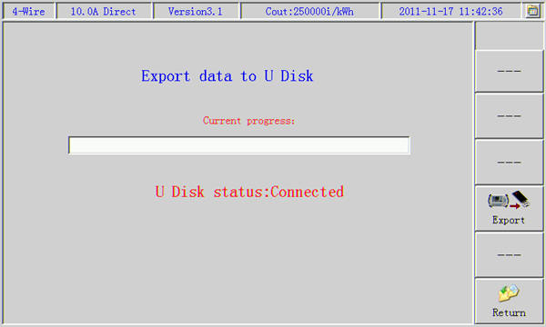

### 7.9.3 Export Data to U Disk

The function of this operation is to export testing data from MCST01 to memorizer of U disk, and import testing data to PC machine data management software from U disk.

In other menu interface, press number key 7 or click “068” to enter into interface of this function.

### 7.9.4 PT Secondary Voltage drop

Electric energy is composed of three parts: mutual inductor, electric energy meter and cable connecting both (namely secondary circuit of mutual inductor). As for current transformer （CT）, since its secondary circuit is connected in series to measurement circuit, the current will not change, as for voltage transformer, due to the existing (such as cable itself, contact of terminal blocks, fuse, air-break switch and so on) of impedance in the secondary circuit, part of the voltage will be consumed, which will result in inconformity between secondary export voltage and voltage at the end of electric energy meter, thus lead to electric energy measurement error, and also cause electric quantity loss of electric power department.

**Wiring:**

**a.** Measurement of PT secondary voltage drop must be live-wire work, therefore operators should abide by *Safety Regulation*;

**b.** It would be better to check the insulation condition of each measuring line by using universal meter to avoid power grid and equipment accident caused by short circuit of measuring line;

**c.** Wiring should follow the order of instrument panel and terminal on the cable car first, then the circuit to be tested, when connecting circuit to be tested, PT side is first, then connect electric energy meter side;

d. When testing three phase three wire, pay attention to spare zero phase wire end (black) to avoid contacting with other circuit.

e. When wiring or disconnecting, best close power supply of instrument first .

**Mode of Wiring:**

There are four modes of wiring for on-site measurement as per the difference of instrument and location of wire car.

1. Mode for PT side, wire car and instrument are together



PT Wh

|  |
| --- |
| PT Wh  MCST01 |

* 1. Mode for PT side, wire car and instrument are separated



PT Wh

|  |
| --- |
| PT Wh  MCST01 |

* 1. Mode for meter side, wire car and instrument are together



PT Wh

|  |
| --- |
| PT Wh  PT3000 |

|  |
| --- |
| PT Wh  MCST01 |

1. Mode for meter side, wire car and instrument are separated

PT Wh



|  |
| --- |
| PT Wh  MCST01 |

In extended function interface, press number key 2 or click “****” to enter into PT secondary voltage drop measurement interface as shown below:

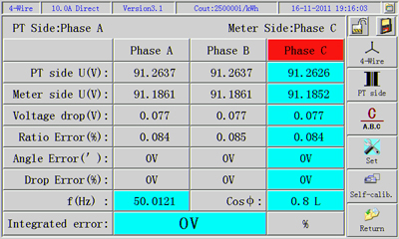

Fig. 7.9.4.a PT Secondary Voltage Drop Measurement Interface

**Functions of Menu Key：**

** ：** Switch as per wiring method of electric energy meter.

** ：**Switch as per wiring method when measuring PT secondary voltage drop, respectively are “PT Side” and “Meter Side”;

 ：Switch phase of measuring data, Phase A, Phase B or Phase C; no Phase data when wiring method is three-wire;

 ：Enter into parameter interface, input load average power factor;

 ：Enter into self-calibration interface, and password is needed;

 ： Return to the previous interface.

Real average power factor of current load should be inputted when measuring comprehensive error. Press menu key “” to enter the following interface:

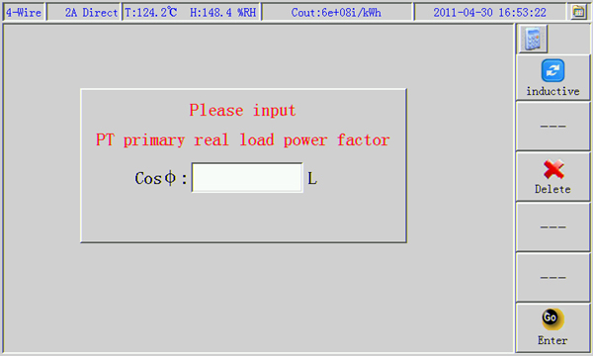

Fig. 7.9.4.b Power Factor Inputting Interface

Press menu key “” and input corresponding password to enter into self-calibration interface as shown below:

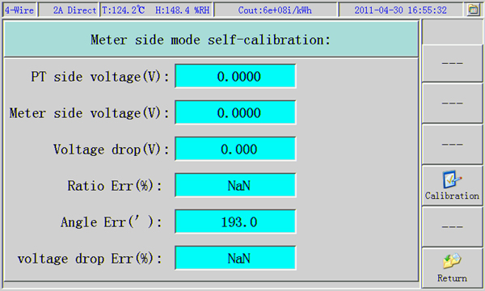

Fig. 7.9.4.c PT Secondary Voltage Self-calibration Interface

Self-calibration for PT Side :

In measurement of PT side, put the instrument at PT end to measure, cable car is connected in series between instrument and electric energy meter, due to long cable and varieties of impedances, part of the signals transmitted from meter side will be consumed and bring error to measurement, so error data should be saved in the instrument in advance, in actual measurement, the measured data can be gotten after automatically deduct the error. PT side self-calibration is to measure error data brought by external factors under this method and save them.

Error data of matched cable is saved when the instrument leaving the factory, if the users change the cable and it should be measured again.

Since the self-calibration data influences the correctness of instrument measurement result directly, so the password is needed when entering the self-calibration every time to avoid covering of correct self-calibration data caused by misoperation.

Self-calibration for Meter Side

In self-calibration of WH side, it means measuring putting the instrument at the end of electric energy meter, cable car is connected in series between instrument and electric energy meter, due to impedances part of the signals transmitted from PT side will be consumed and bring error to measurement, so error data should be saved in the instrument in advance, in actual measurement, the measured data can be gotten after automatically deduct the error. Self-calibration of end mode is to measure error data brought by external factors under this method and save them.

Error data of matched cable is saved when the instrument leaving the factory, if the users change the cable and it should be measured again.

The wiring of calibration is similar to that of PT side, it’ sonly need exchange two signal inputting ends, displayed interface of instrument is the same with that of PT side.

**Note: Instrument A phase voltage terminal is inserted into PT side; Instrument C phase voltage terminal is inserted into WH side; self-calibration password of PT side: “111111”, self-calibration password of WH side is: “222222”!**

### 7.9.5　PT Secondary Load Test

In extended function menu interface, press number key 3 or click “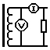” above “3.ＰＴ　Load” to enter into PT secondary load measurement interface, which is shown as follows:

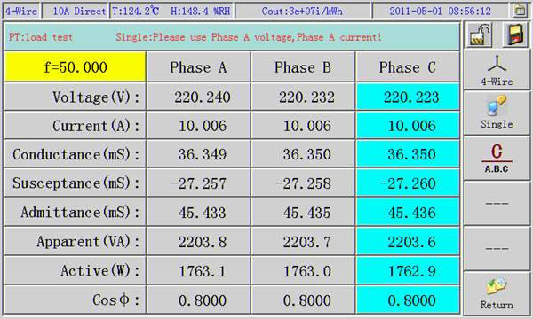

Fig7.9.5　ＰＴ Secondary Load Testing Interface

On the basis of wiring mode of PT secondary electric energy meter, press menu key “****” to select four wire three phase or three wire three phase. 3 circuits can be measured at the same time or one after another, press “” to select.

0000**Note: in one-way measurement, instrument A phase voltage terminal and A phase current 5A split-core type meter should be used！**

### 7.9.6 CT Secondary Load Test

In extended function menu interface, press number key 4 or click “” above “4.CＴ　Load” to enter into CT secondary load measurement interface, which is shown as follows:

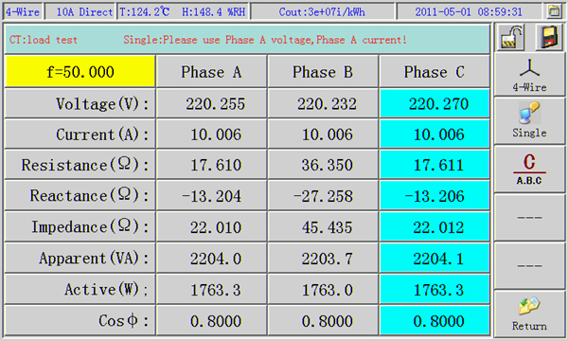

Fig. ７.９.6　CＴ Secondary Load Testing Interface

The operational method and wiring mode is the same as that of PT secondary load test.

# Chapter VIII Instrument System Parameter Setting

Press functional key “” on the instrument panel to enter into the main menu interface, and then press number key 7 or click “” directly to enter into selecting interface of system parameter setting, which is shown as follows:

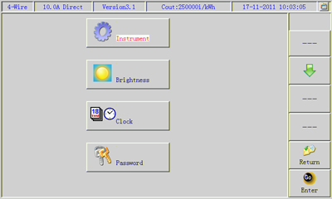

Fig. 8 Selecting Interface of Parameter Setting

Select the setting system parameter bar through menu key “” or click the setting parameter bar directly, the one with white background is the selected parameter bar, then press menu key “” to confirm and enter into interface for system parameter setting of each item.

## 8.1 Instrument System Parameter Setting

Enter into the following functional interface as the aforesaid methods:

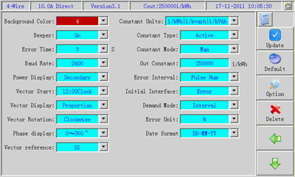

Fig. 8.1 System Parameter Setting Interface

The following relevant parameters can be set in this interface:

* Background color: background color for measuring data, users can select proper background color as per the outside ray of light. There are totally five colors to select, and the system acquiesces in the first one;
* Beeper: on, off function of buzzer, select “On”, the buzzer will make a sound when operating the button or refreshing error data, select “Off”, it won’t make a sound, and the system acquiesces in “On”.
* Error time: in the calibration of error, the time base when the number of pulses is selected as “Automatic”; “3,5,8,10” seconds, and the system acquiesces in 3 seconds.
* Baud rate: communication baud rate of RS-232, it can be selected among“2400, 4800, 9600, 19200, 28800, 38400, 57600, 115200”, and the system acquiesces in9600；
* Power display: the instrument falls into “Primary” power display and “Secondary” power display, and the system acquiesces in “Secondary”.
* Vector point: starting location when drawing vector diagram, it can be selected among “12：00Clock” and “3：00Clock”, and the system acquiesces in “12：00”；
* Vector display: there are “fixed length” and “proportion”, fixed length: length of vector is fixed; proportion: length of vector indicates amplitude. And the system acquiesces in “proportion”.
* Vector rotation: direction of rotation of vector diagram, falls into clockwise and anticlockwise, and the system acquiesces in “clockwise”.
* Phase display: mode of display of phase, it can be selected among “0~360°” and “±180°”, and the system is acquiesces in “0~360°”;
* Vector reference: basis reference when drawing vector diagram, if select “U1”: taking A phase voltage as basis reference; if select “I1”: taking A phase current as basis reference. The system acquiesces in “U1”.
* Constant dimension:Dimensionless constants set.
* Constant type: electric energy type represented by the constant outputted by this instrument, active (power) or reactive (power). The system acquiesces in “active”.
* Constant mode: mode of constant outputted by the instrument; falls into “Auto” and “Man”. If select “Auto”: the system changes the constant automatically as per the current maximum voltage and measuring span of current. See the following outputting constant formula for the computing method of outputting constant of each gear. If select “Man”: the wanted constant value can be inputted, and the instrument can output constant under any rang of measuring. The system acquiesces in “Auto”.
* Outputting constant: if the mode of constant is selected as “Auto”, the parameter box will change into gray, which indicates it is not allowed to input; when the mode of constant is selected as “Man”, constant value can be inputted. The range is 1~250000, and the system acquiesces in 250000；
* Error interval: mode of display of error interval in error calibration. Fall into “Pulse Num” and “Progress Bar”
* Initial interface: the interface when the system entering the measuring mode. Fall into “Comprehensive Measurement” and “Main Menu”, and the system acquiesces in “Comprehensive Measurement”.
* Demand mode: Test method to be devided into “Interval” and “Slip”

**Output Constant Formula:**

C = 3600000/(Un*In*3)*fn(60000);

C：Electricity meter constant;

Un: maximum voltage rated measuring range the instrument in;

In: maximum current rated measuring range the instrument in;

fn: rated frequency outputted by the instrument, that of this instrument is 60kHz;

Functions of Menu Key:

 ：Return to the previous interface;

 ： Default system parameter;

 ： Select the optional parameter item;

 ： Delete the inputted false character;

 ：Move the cursor left and right to the inputted parameter item;

 ：Move the cursor up and down to the inputted parameter item.

## 8.2 Instrument Brightness Setting

In system parameter setting interface, select “brightness adjustment” to enter into brightness adjustment interface, which is shown as follows:

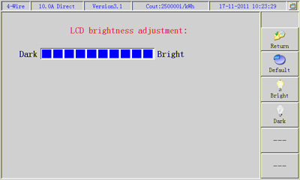

Fig. 8.2 Brightness Adjustment Interface

Brightness of the instrument can be set in this interface.

Press menu key “”, brightness of LCD will be brightened; press menu key “”, brightness of LCD will be darkened. Press menu key “” to return to the previous interface.

## 8.3 Instrument System Time Setting

In system parameter setting interface, select “time setting” to enter into time setting interface, which is shown as follows:

Press number key and menu key 4 “”, menu key 6” ” to input the current date and time: press menu key 5 “” after inputting correctly, the instrument will start with the inputted time. 2 digits each for year, month, day, hour, minute and second. It will jump to the next time parameter automatically after the current time parameter is inputted completely, or press menu key 6 “”to move to the time parameter needing modification to modify.

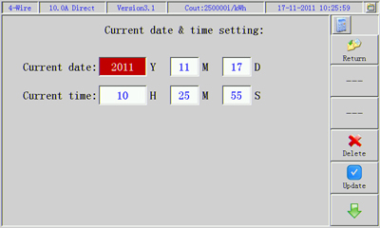

Fig.8. 3 Time Setting Interface

# Chapter IX Data Management

Data management interface mainly accomplishes consultant of calibrated meter information and so on operations. In main menu interface, press number key 9 or click “” to enter into the following interface:

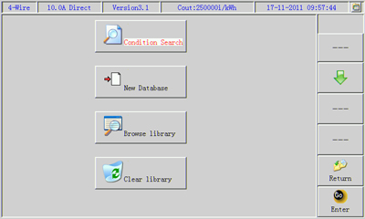

There are 4 **subfunction** menus in this interface:

1.  ：Search the saved data record in the instrument as per the searching conditions set by the users;

1.  ：Users establish mater record parameter to be calibrated manually;
2.  ：Browse relevant information of meter record saved in the instrument in order;
3.  ：Clear away the meter record information saved in the instrument. (Password is needed).

Press menu key “” and move the cursor to the wanted functional item or click the functional block, then press menu key “” to enter into each functional page.

## 9.1 Condition Searching

In this interface, users can set searching conditions as per demands thereby look up data record information of a certain meter quickly and accurately.

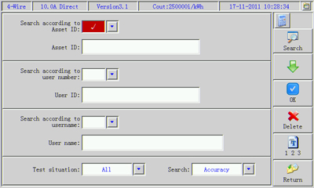

There are 3 optional conditions: a. Search according to Asset ID; b. Search according to user number; c. Search according to surname. Only one of them can be selected, when the condition box shows “√” indicating the condition is valid. And only valid condition entry parameter can set modification, and invalid condition entry parameter can not set modification.

Functions of menu keys:

 ：Search eligible meter recorded information in the meter library as per the setting conditions;

 ：Move cursor to parameter item needing setting;

 ：Select wanted parameter item;

 ：Delete the inputted false character;

 ：Switch the input method, switch among “figure”, “letter”, “Pinyin”, “Symbol” in turn.

 ：Return to the main menu interface.

There are 4 testing accomplishment box options in the searching condition: “All”、 “None tested”、“Part tested”、“All tested”; which are indicating whether the test items have been conducted or not. “None tested” indicates unfinished of all test items, “Part tested” means record data that have received several test items, “All tested”means record data that have received all test items.

Searching: fall into fuzzy and accuracy. Fuzzy is fuzzy search (for example: input Asset ID of 2006 can search out all assets including 2006); accuracy search: is match whole word only (for instance: 200612150001 must be inputted to search out Asset ID of 200612150001).

## 9.2 New Library

This interface is basically the same with parameter setting interface. The only difference is to change the menu key 6 to “”, press menu key 6 to save after inputting the parameter.

## 9.3 Browse Library

The interface is shown as follows, meter record saved in the instrument is listed orderly in the interface.

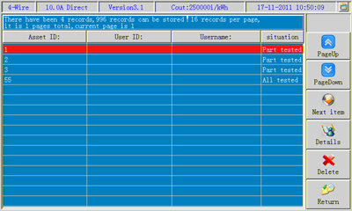

Turn a new page through menu key 1 “”, menu key 2 “”, menu key 3 “” to find the wanted meter information, press menu key 4 “” can see the stored information of the meter,which are shown as follows. Press menu key 5 “” to delete the selected meter resorded information.

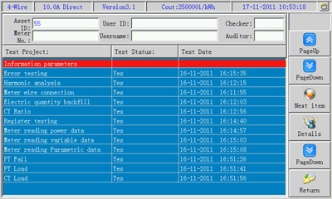

Test accomplishment conditions of each data item of the meter are listed in the interface, press menu key 3 “” can select the data item to be looked up. Press menu key 4 “” can display detailed information of data of the tested item. The displayed interface is the same with test interface. See the following error measuring data item saving data interface.

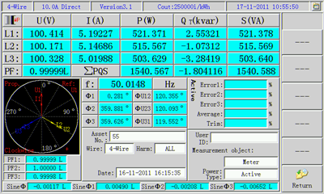

## 9.4 Clear Library

Select this functional interface can clear all the meter record information in the meter library. Password should be set when clearing (Clearing password: 777777).

# Chapter X Interface and Definitions

## 10.1 Definition of Pulse Interface

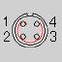

1： photoelectronic pulse input signal

2：ground

4：+5V

## 10.2 Definition of Serial Communication Interface



2：data string inputting TXD

3：data string outputting RXD

5：ground

7：RS485-A

8：RS485-B

# Chapter XI Accessories

**Standard** **Accessories**

Photoelectronic sampler 1

Electronic meter pulse calibration line 1

232 connecting line 1

485 connecting line 1

current clamp 3

Voltage testing line 1 set

Current testing line 1 set

Mating PC management software disk 1

**Optional Accessories**

Photoelectronic sampler 1 (2 are needed for main and auxiliary meters calibration)

Electronic meter pulse calibration line 1(2 are needed for main and auxiliary meters calibration)

100A/200A/500A/1000A current clamp 1~3